Standards for the California Catechist Certification
Catechist Formation Course
Office of Religious Education and Youth Ministry
Archdiocese of San Francisco
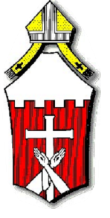

 | Class Title/Instructor | Date | Location | Hours
Tasks of Catechesis
Knowledge of Faith
6 hours needed
- Revelation/Faith
- Scripture
- Tradition
- The Creed
- Trinity & Image of God
- Christology (Jesus Christ)
- Ecclesiology (Church)
- Mary & Saints
- Life Everlasting
Liturgical Life
6 hours needed
- Paschal Mystery
- Sacramental Theology
- Liturgy
- Eucharist
- Sacraments of Initiation
- Sacraments of Healing
- Sacrament at Service of the Community
Moral Formation
6 hours needed
- Dignity of Human Person
- Sin, Grace, Redemption
- Ten Commandments, the Great Commandment, The Beatitudes
- Moral Principles
- Conscience Formation & Moral Decision Making
- Virtue and Gospel Values
- Catholic Social Teaching
- Lifelong Conversion
Christian Prayer
4 hours needed
- Prayer in the Christian Life
- Spirituality
- Prayer Forms
- Lord’s Prayer
- Leading Prayer
Communal Life
4 hours needed
- Communal Character of Life in Christ
- Apprenticeship in Christian Living
- Ecumenical Dimension
- Multicultural Reality
- Safe Environment
Missionary Spirit
4 hours needed
- Evangelizing Spirit
- Discipleship
- Call of Laity in Mission and Service
- Interreligious Dialogue
Nature and Purpose of Catechesis
6 hours needed
- Initiating and Ongoing Catechesis
- Catechumenate as Model & inspiration
- Evangelizing Catechesis
- Inculturation
- Faith & Human Development
- Authentic Presentation of Christian Message
- History of Catechesis
Methodology
6 hours needed
- Divine Methodology
- Elements of Human Methodology
- Learning Styles, Teaching Styles |  | - Check with your DRE/CRE or Youth Director while working on this form and upon completion of your form  - Put as much information for the last three years as you can for certification  - When completed your DRE/CRE or Youth Director will evaluate your teaching and write a letter to the Office of Religious Education stating you can be certified under the California Catholic Conference of Bishops and the Archdiocese of San Francisco.  Every three years with ten hours of classes each year.  Office of Religious Education and Youth Ministry  One Peter Yorke Way, SF 94109  415-614-5650
- Technology & Catechesis
- Resources
- Lesson Planning
Other classes –not sure where it fits

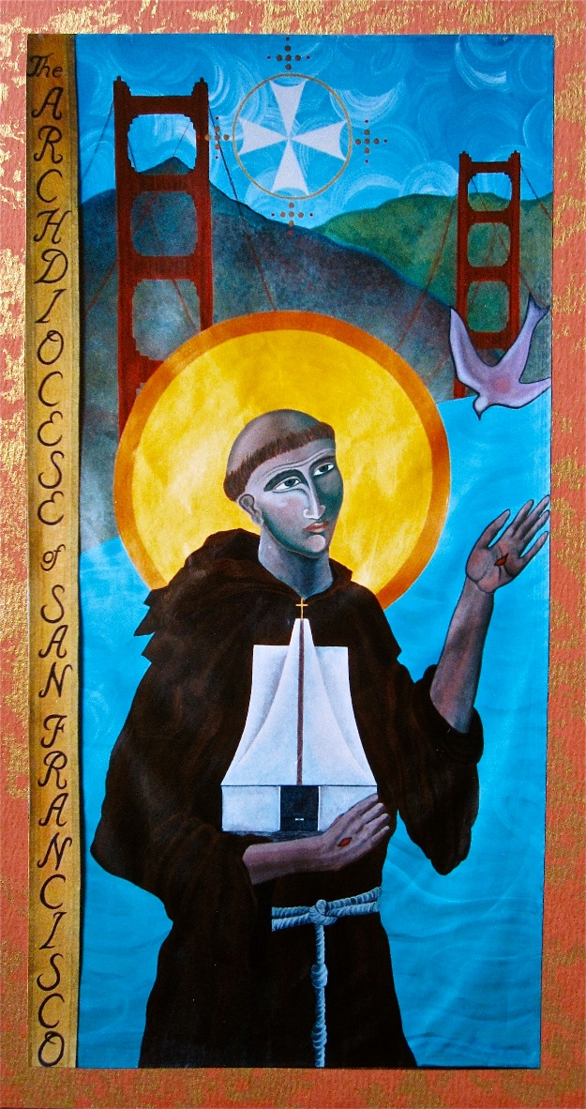
Remember
Renewals

